TEST REPORT    Ford Motor (Nanjing) Research and Engineering Co., Ltd.  Asia Pacific Region  Product Development |  | DISPOSE of Copies  (Black Stamped) by  RETAIN Master. Copy  (Red Stamped) thru  GIS Item No  2052
PROGRAM: 707  Milestone: R00版本 | TO: PMT5  DVP Team:  REQ ENG: XXU91
RQMT ID:  RQMT TITLE: Message Center Client  PRIORITY LEVEL: Secondary | DVM ID:  DVM TITLE:  DVM TYPE: Vehicle
PART NUMBER: N/A  NOTE: | Vehicle: 台架  (VIN: )  Location: REC, Nanjing, China
RESULT:
FAIL

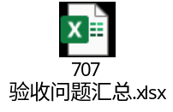

Tool CALIBRATION:
/
TESTED BY:  XXU91 | APPROVED BY:

